

GRADUATION PROJECT I

BACHELOR OF COMPUTER AND INFORMATION SYSTEMS CCIS – SOFTWARE ENGINEERING

كِسَاء

Abaya Shopping – A M-Commerce Application

Prepared by

Ghada Frahan - 201312026

Razan AlKhudair - 201312231

Supervised by

Dr. Vani Vasudevan Iyer

Academic year 2017

Spring Semester

Abstract

The purpose of our system is to unify all Abaya designers in the gulf region to sell their Abayas in one platform, instead of using social media accounts to sell them. A survey has been conducted for customers, and the results has confirmed the issues. Our system will give the opportunity for Abaya designers to feature their product in a wide customer base. In the same way, customers will get the opportunity to shop for a wide variety. Initial planning for development is set for database schema and functional design.

**Keywords:** Abaya designers, M-commerce, Mobile Application, C2C, Web Application.

Acknowledgment

In performing our project, we had to take the help and guideline of some respected persons, who deserve our greatest gratitude. Dr. VaniVasudevan Iyer, Senior Project Supervisor and an Assistant/Professor at Al Yamamah University, thank you for giving us a valuable help and guideline.

We would like to expand our deepest gratitude to Al Yamamah University and all our Instructors for these past four years.

To our mothers, you have nurtured our learning, supported our dreams, it is the greatest gift anyone has ever given us. We owe it to you.

Lastly, we wish also to express our deep sense of gratitude to our families and friends for the continuous help and support.

Ghada Farhan

Razan AlKhudair

Table of Contents

**Abstract** ……………………………………………………………………..……… 2

**Acknowledgment** …………………………………….……..……………………… 3

**Table of Contents** …………………………………………………....……………... 4

**List of Figures** ………………...…………………….…..………………………….. 6

**List of Tables** …………………………………….………..………....……….…….. 7

**CHAPTER 1: INTRODUCTION** ………………………..………………….……. 8

1. **Background** …………………………………….……..…………....…………. 9
2. **System Study** …………………………………….……..…………....………... 9
   1. Existing System ………………………………..…………………... 9
   2. Drawbacks in the Existing System ……………..………..………… 9
   3. Need for the Proposed System ………………….………………… 10
3. **Proposed System** …………………………………….………………....……. 10
   1. Objectives of the Proposed System ……………….……………… 10
   2. Project Scope .…………………………………………………….. 11
   3. Project Constraints ……..……………………….………………… 11
   4. Features and benefits ……………………………………………... 11

**CHAPTER 2: LITERATURE REVIEW** …………………….……..……..….… 13

# Related Works …………………………………….………………....…….…14

# Customer’s Survey & Evaluation ………………………....………..…….… 15

# Survey questions ……………………………….…….………..….. 15

# Survey Results & Inferences …………………….………………... 16

# Designer's Survey & Evaluation ………………………….………….……... 19

# Survey questions ………………………………………………….. 19

# Survey Results & Inferences …………………...….……………… 20

# Tools Used .……………………………………………………….. 22

**CHAPTER 3: REQUIREMENTS ANALYSIS AND DESIGN** …….……..…… 23

1. **Proposed System Analysis** …………………………………….……….……. 24
   1. Activity Diagram …………………………………………………. 24
   2. Use Case Diagram ………………………………………………... 26
   3. Use Case Specifications .…………………………………….……. 27
   4. Class Diagram .…………………………………….….…….…….. 29
   5. ER Diagram ………………………………………………………. 30
   6. Software and Hardware Requirements ………………………….… 31
   7. Project Plan …………………………………………………….…. 32
2. **Proposed System Design** …………………………………….…………….… 34
   1. Functional Design .………………………………………….…….. 34
      1. Functional Requirements …………………………………… 34
      2. Methods …………………………………………………….. 35
   2. Database Design ….………………………………………………. 37
      1. Schema ….………………………………………………….. 37
      2. tables ………………………………………………………... 38
   3. Website Prototype ………………….……………………….…….. 40

**CHAPTER 4: DEVELOPMENT TOOLS** ………………………………...……. 42

**CHAPTER 5: CONCLUSION AND PLANAHEAD** …………………..….…… 48

**CHAPTER 6: REFERENCES** ……………………………………………...…… 50

**APPENDIX A: CUSTOMER’S SURVEY RESULT SCREANSHOTS**…....…. 53

**APPENDIX B: DESIGNERS’ SURVEY RESULT SCREANSHOTS**……..…. 59

List of Figures

Figure 2.1: Survey on shopping preferences. ……………………………...….… 17

Figure 2.2: Survey on percentage of preventative reasons. …………...…..…..… 17

Figure 2.3: Survey on sells preferences. ………………………………..……...… 21

Figure 2.4: Survey on interest to be involved in creating the app. ……..………… 22

Figure 3.1: Activity Diagram - Designer registration process. ………………..… 25

Figure 3.2: Activity Diagram - Customer ordering process. …………………..… 25

Figure 3.3: Use Case diagram. …………………………..……………..……....… 26

Figure 3.4: Class Diagram. …………………...…………………………….….… 29

Figure 3.5: ER Diagram. …………………...…………………………………..… 30

Figure 3.6: Plan for Graduation Project 1. ...………………………….………..… 32

Figure 3.7: Plan for Graduation Project 2. ...………………………….………..… 33

Figure 3.8: Database Design - Schema. ...……………………………………...… 37

Figure A.1: Survey on customer’s age. ...………………………………………… 54

Figure A.2: survey on customer’s interest on social media brands. ……………… 54

Figure A.3: Survey on shopping preferences. …………….……………………… 55

Figure A.4: survey on customer interest on Abaya app/website. ………………… 55

Figure A.5: Survey on platform preferences. …………….………………..…..… 56

Figure A.6: Survey on problems in Instagram businesses. ………………...…..… 56

Figure A.7: Survey on percentage of preventative reasons. ………………...….... 57

Figure A.8: Survey on customers’ suggestion. …………….……………….....… 58

Figure B.1: Survey on brand names. …………….………………………….....… 60

Figure B.2: Survey on number of designs. …………….……………………....… 60

Figure B.3: Survey on designers’ monthly orders. ………..…….……………..… 61

Figure B.4: Survey on designers’ monthly earnings. ……..…….………….…..… 62

Figure B.5: survey on sells preferences. ……..…….…………………………..… 62

Figure B.6: Survey on designers’ suggestion. ……………………………..…...… 63

Figure B.7: Survey on interest to be involved in creating the app. …………….… 63

Figure B.8: Survey on preferred contact methods. ………………………….....… 64

List of Tables

Table 2.1: survey on preventative reasons. …………………………………………… 18

Table 2.2: Survey on suggested features. ……………….………………………..…… 18

Table 2.3: Survey on Abaya designers. ……………………………………………..… 21

Table 3.1: use case specifications - Customer Login. …………………………..…..… 27

Table 3.2: use case specifications -View Sales Statistics. …………………………...… 27

Table 3.3: use case specifications - Verify Designer’s Account. ……………………… 28

Table 3.4: use case specifications - Brows Items. ……………………………...……… 28

Table 3.5: Methods - Order. ...………………………………………………..………… 35

Table 3.6: Methods - Item. ...………………………………………………....………… 35

Table 3.7: Methods - User. ...………………………………………..……….………… 35

Table 3.8: Methods - Card. ...………………………………………………...………… 36

Table 3.9: Methods - Comment. ...……………………………………………..…….… 36

Table 3.10: Methods - Cart. ...………………………………...………………..…….… 36

Table 3.11: Tables - Customer. ...……………………………………………..……...… 38

Table 3.12: Tables - Designer. ....……………………………………………..……...… 38

Table 3.13. Tables - Comment. ...……………………………………………..……...… 38

Table 3.14: Tables - Item. ...…………………………………………………..……...… 39

Table 3.15: Tables - Order. ...……………………………………………..……….....… 39

Table 3.16: Tables - Card. ...……………………………………………..…………...… 39

CHAPTER 1: INTRODUCTION

# Background

In recent years, due to the increasing demand on designer Abayas around the gulf countries, Abaya’s stores and designers grew in numbers. Many young females started to utilise their talent and passion for beautiful Abayas to design and sell Abayas from their home. Most of them use fairs and social media, especially Instagram, to reach their audience.

However, inefficient communication and difficulties in reaching the target audience limited the designers to grow larger. Also, customers struggle to get an instant reply to confirm availability and to place orders. Sometimes it takes more than 3 days to get a reply and place the order, because the usual way of communication is through WhatsApp.

A dedicated C2C M-commerce platform will solve all stated problems and will provide the user with easy interface to buy Abayas form different designers in one place. The designers will be able to reach a larger audience from all over the GCC.

# System Study

* 1. **Existing System**

The existing Abaya sales system, had the same concept of unifying all Abaya designers in one platform in a desktop website.

* 1. **Drawbacks in the Existing System**

In the existing system for Abaya sales, it had a workload for the admin because he/she will be registering the designers, but in case of the proposed system the designer will be registering on their own. Also, the existing system is a desktop website in which there’s a noticeable decrease in the desktop websites usage compared to mobile applications in the proposed system.

* 1. **Need for the Proposed System**

Our platform will offer single location where Abaya designers and customers can meet. In addition, the demand on designer Abaya’s is showing a noticeable increase in the recent years. Our targeted users are women who live in the gulf countries.

# Proposed System

The proposed work will provide single platform for all Abaya’s designers and stores to sell their designs. It will give small business the opportunity to grow and reach for larger audience. This proposed work will enable the user to easily search and buy Abayas from different stores from all over the gulf countries in one place.

1. **Objectives of the Proposed System**

* To offer a single platform for Abaya designers and costumers to meet.
* To support small businesses.

1. **Project Scope**

The system features will include sorting Abayas to new arrivals by default, and the user can choose later to sort it by colour, size, price, and shipment location. After the customer chooses the Abaya, the customer will be requested to fill his/her name, mobile number and email. Then the customer must fill the Abaya details. After submitting the order, an email should be sent to the designer contains the order details.

1. **Project Constraints**

* The system will support shipments to the gulf countries (KSA, UAE, Kuwait, Bahrain, Qatar, Oman) only.
* Platforms: iOS, Android mobile app.
* Payment method: Visa, MasterCard, cash on delivery.
* The software will be in English.

1. **Features and benefits**

* Provide a C2C M-commerce platform for Abaya designers to sell their Abayas.
* Enable the users to order Abayas form variety of boutiques.
* Enable the user to specify the size, color and any other modification on the Abaya and the scarf.
* Feature the new arrivals in the home page.
* Enable user to create an account which includes name, email, phone, and user location.
* Enable the users to search by brand (boutique).
* Enable the user to sort the items by size, color, price, shipment location and brand name.
* Send an email to the boutique about new order include: order number, order details, and the user's contact information.
* Enable the users to rate the boutique.
* Enable the users to rate the product.
* Use the data gathered for analysis report and provide them to the designers.
* Use the users’ data for marketing purposes.

CHAPTER 2: LITERATURE REVIEW

# Related Works

The importance of E-commerce in the gulf region has been increasing in the past years, Abaya designers has been using Instagram pages to sell their products, and because Abayas are only cultural based seller it is apparent that the number of previous published non-commerce projects is few.

A mobile application is found for Abaya sales “Abayti”, it’s an m-commerce application, but the user interface is not good in which it discourages the user to shop, dark colors (brown and black), uncommon look and feel interface and unease of performing tasks. In addition, another mobile application called “Sufanh” for Abaya sales, had a slow loading of the content. The significance of UI is discussed in an E-commerce paper [1]. It confirms the importance of a good user interface specially in an E-commerce websites, confirming that users of online stores usually make their decision within a few seconds whether to keep browsing or leave the website

Security is a significant part of E-commerce, and because gaining customer’s trust is difficult, many projects work to apply specific technologies for it [2]. Although it is still an issue many projects came up with cash on delivery payment method in which payment is done when the product is delivered to its destination, which this is what this project is aiming to follow.

In current E-commerce websites and M-commerce like “Muslim Shop” most of them go with buying the goods from the designers then selling it to the customers, but what our system will follow a vendor management where they have the liberty to sell their items.

# Customer’s Survey & Evaluation

The survey contains 9 questions. The goal of this survey is to understand more about the problems the customers are facing with the existing solution(Instagram).

* 1. Survey Questions

1. What is your age?

* Less than 16
* 16-24
* 25-34
* 35-44
* 45 and above

2. How do you usually buy your Abayas?

* Online (Instagram and others)
* Bazaars, carnivals and other events
* Physical stores (malls)

3. Do you like Abaya's brands available for sale on social media?

* Yes
* No
* Sometimes

4. Do you prefer shopping from Abaya's designers, or stores?

* I prefer Abaya's designers more
* I prefer traditional stores more

5. would you be interested if there’s an online app or website that will join all Abaya designers together?

* YES, I would definitely be interested.
* Yes, I would try it
* Maybe
* No, not interested

6. What platform do you prefer for shopping?

* IOS apps
* Android apps
* Website
* Other (please specify)

7. What kind of problems do you face when buying from Instagram and other social media?

* Sizing and customization issues
* Placing orders take a long time
* Lack of information about the Abayas (materials, availability)
* The number of designers is large, hard to check them all out
* Other (please specify)

8. Did any of the problems mentioned above held you back from buying from Instagram?

* Yes
* No
* Sometimes

9. What features would you suggest to be implemented in such software?

* 1. Survey Results & Inferences

Demographic:

A total of 66 responses were collected and analyzed. All the respondents were females. (60.6%) ages ranges between (16 - 24) years old, (34%) of the respondent’s age were between (25 – 34) years old, (4%) were between (35 – 44) years old.

Analysis:

(86.36%) of the respondents like or sometimes like the Abaya’s brands available on social media. After ignoring the sample who stated that they prefer traditional Abaya’s, only (61.4%) of the respondents, who liked the Abaya’s brands, prefer shopping on traditional stores rather than shopping from the designers, showed in (Figure 2.1), and (85.97%) of them say that some problems have been the reason that prevented them from buying designers Abaya’s, showed in (Figure 2.2). (Table 2.1) shows a list of these problems, and (APPENDIX A) shows the results without slicing the data.

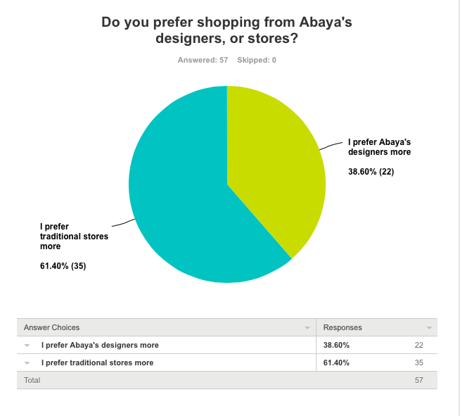

Figure 2.1: Survey on shopping preferences.

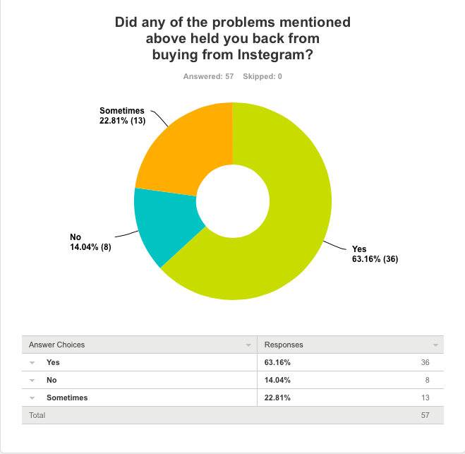

Figure 2.2: Survey on percentage of preventative reasons.

|  |  |
| --- | --- |
| Issue | Respondents |
| Sizing and customization issues | 43 |
| Placing orders take a long time | 16 |
| Lack of information about the Abayas (materials, availability) | 35 |
| The number of designers is large, hard to check them all out | 16 |
| Safety issues | 1 |
| High prices | 8 |
| The image doesn’t match the real Abaya | 1 |

Table 2.1: survey on preventative reasons.

(66.67%) of respondents say that they would be interested if there is an Abaya shopping online system, (24.24%) say that they might be interested, and only (9.09%) say that they are not interested. Most users prefer that the shopping system to be an iOS/Android app, that is (83.33%), and (48.48%) of them prefer a website.

(Table 2.2) shows the respondent’s suggestions to improve the system. Therefore, based on the survey results, the following features are added in the proposed system. Also, the proposed system will attempt to solve all the problems the customers are facing.

|  |  |
| --- | --- |
| Features suggested | Respondents |
| Convenience | 1 |
| Ease of use | 1 |
| Cash option as a payment | 2 |
| Delivery and tracing | 4 |
| Online payment | 1 |
| Details on the Abaya’s (fabric, texture…etc.) | 2 |
| Standard sizing | 3 |
| Promo codes | 1 |
| To sort Abayas based on designer | 1 |
| Customization (color and design) | 1 |

Table 2.2: Survey on suggested features.

# Designer's Survey & Evaluation

The survey contains 9 questions. The goal of this survey is to get in touch with the designers, and to understand the real market for designer’s Abaya.

To conduct this survey, we have contacted 48 designers through WhatsApp, and we got 8 responses.

1. Survey Questions

1. What is your age?

* Less than 16
* 16-24
* 25-34
* 35-44
* 45 and above

2. How do you usually buy your Abayas?

* Online (Intagram and others)
* Bazaars, carnivals and other events
* Physical stores (malls)

3. Do you like Abaya's brands available for sale on social media?

* Yes
* No
* Sometimes

4. Do you prefer shopping from Abaya's designers, or stores?

* I prefer Abaya's designers more
* I prefer traditional stores more

5. would you be interested if there’s an online app or website that will join all Abaya designers together?

* YES, I would definitely be interested.
* Yes, I would try it
* Maybe
* No, not interested

6. What platform do you prefer for shopping?

* IOS apps
* Android apps
* Website
* Other (please specify)

7. What kind of problems do you face when buying from Instagram and another social media?

* Sizing and customization issues
* Placing orders take a long time
* Lack of information about the Abayas (materials, availability)
* The number of designers is large, hard to check them all out
* Other (please specify)

8. Did any of the problems mentioned above held you back from buying from Instagram?

* Yes
* No
* Sometimes

9. What features would you suggest to be implemented in such software?

1. Survey Results & Inferences

Demographic and Analysis:

A total of 8 responses were collected and analyzed. The designers who have responded are shown on (Table 2.3).

(6/8) of the respondents say that they would be interested if there is an Abaya shopping online system that helps them to sell their designs, (Figure 2.3). When asked to be involved in the process of creating the app, (5/8) say that they want to be one of the first to hear about this app, (3/8) say that they want to be updated, and give my feedback when needed, and only (1/8) say that they don’t want to be involved, (Figure 2.4).

|  |  |  |  |  |
| --- | --- | --- | --- | --- |
| Respondent Instagram handler | Followers | Orders/  month | Designs/year | Earnings/ month |
| @Abayaalfzr | 15.7K | 17 | 10-20 | 3K-10K SR |
| @abayapassion | 19.6K | 6 | 20-30 | - |
| @Abaya_by_n | 6.5K | 15 | 10-20 | - |
| @ Orion.abaya | 241K | 100 | More than 30 | 10K-20K SR |
| @Abayat_guin | 153K | 80 | 20-30 | More than 20K SR |
| @Abaya_dialakabbara | 23.2K | 11 | 10-20 | - |
| @Abayaboutique | 198K | 10 | More than 30 | 3K-10K SR |
| Anonymous | - | 25 | More than 30 | 3K-10K |
| Average | 83.8K | 33 |

Table 2.3: Survey on Abaya designers.

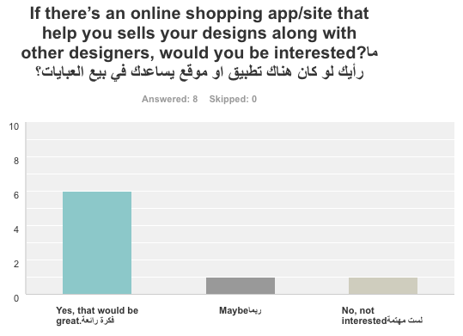

Figure 2.3: Survey on sells preferences.

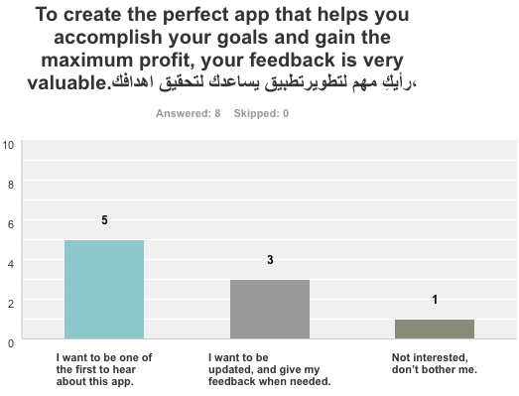

Figure 2.4: Survey on interest to be involved in creating the app.

1. Tools Used



SuveyMonkey

SurveyMonkey [3] is an online survey software as a service company. It provides free, customizable surveys, data analysis, sample selection, and data representation tools.

CHAPTER 3: REQUIREMENTS ANALYSIS AND DESIGN

1. **Proposed System Analysis** 
   1. **Activity Diagram**

An activity diagram of the designer registration process is shown in (Figure 3.1). Assuming that the designer has already done the initial registration, the next step is to starts filling in the detailed information about the boutique, such as logo, bank information, etc., then uploading and posting the item after validation.

(Figure 3.2) shows an activity diagram of the ordering process. The diagram starts assuming that the customer has already registered. It shows the activity process from browsing, item selection, adding to the cart, through the checking out process.

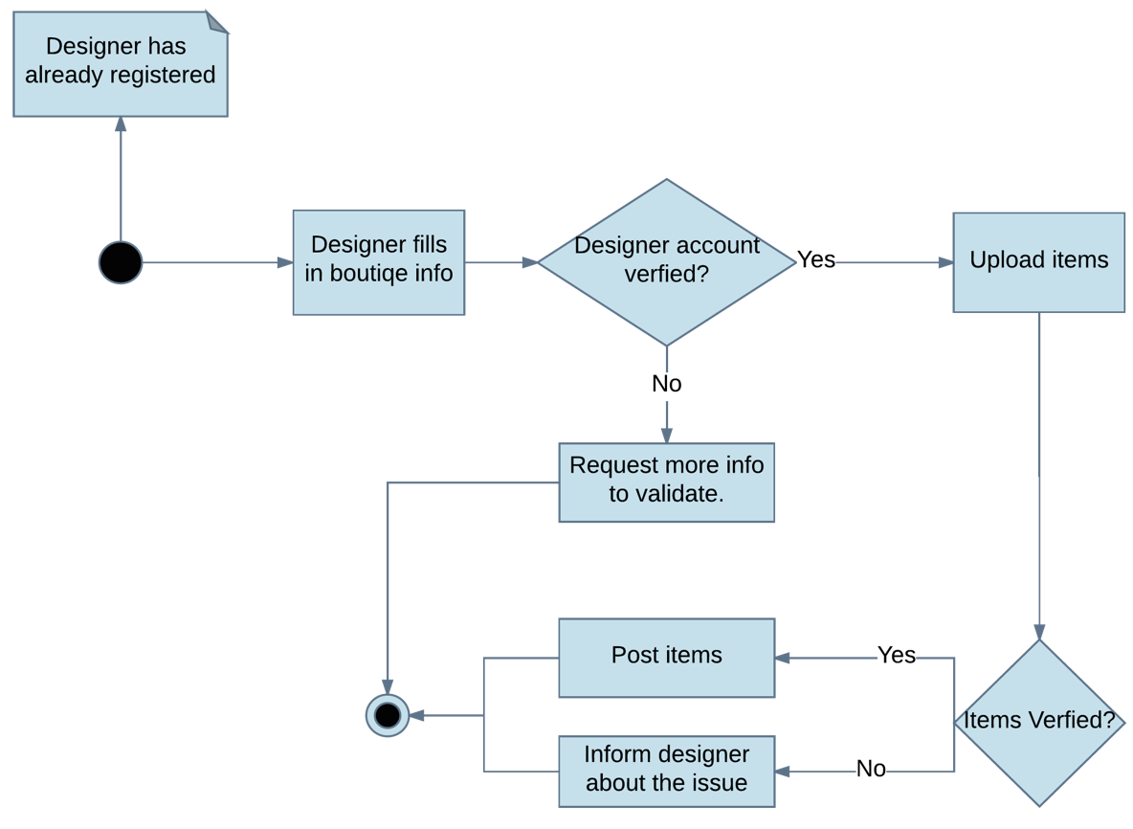

Figure 3.1: Activity Diagram - Designer registration process.

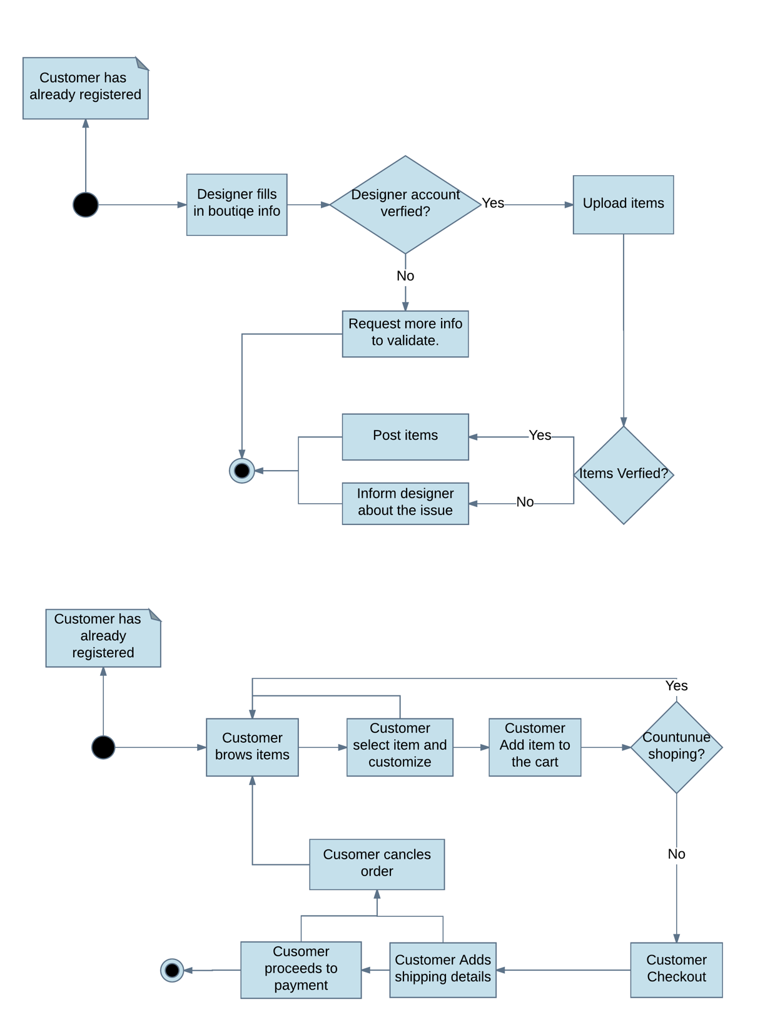

Figure 3.2: Activity Diagram - Customer ordering process.

**3.1.2. Use Case Diagram**

A main use case diagram showed in (Figure 3.3), showing the significance and major tasks that will be performed by the customer, designer, and admin.

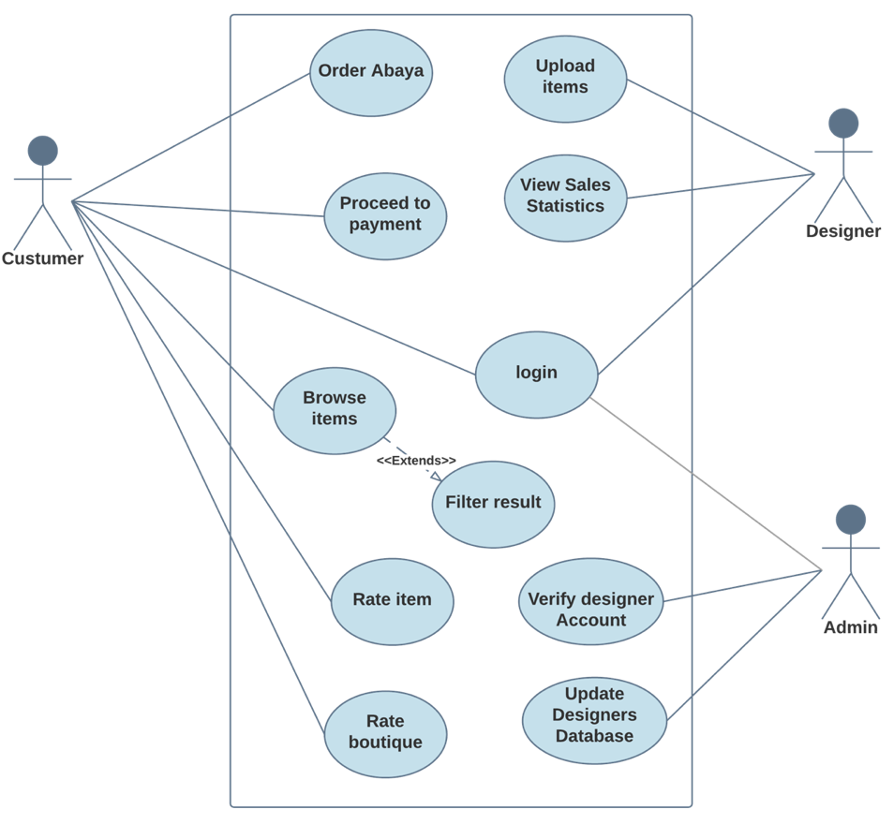

Figure 3.3: Use Case diagram.

**3.1.3. Use Case Specifications**

|  |  |  |  |
| --- | --- | --- | --- |
| Use Case ID: | 1 | **Use Case Name:** | Customer Login |
| Actors: | Customer | | |
| Description: | For the customer to make an order or view past orders, the customer must login to his/her account. | | |
| Preconditions: | 1. An account must be previously created 2. Email and password must be correct | | |
| Post conditions: | 1. Application will show the default page of the app. 2. The profile page will be showing the account details. 3. Application will show past orders if found. | | |
| Normal Flow: | 1.1 Customer clicks the login button  1.2 System takes the user to login page  1.3 Customer enters login details  1.4 System checks for entered information  1.5 Login successful | | |
| Exceptions: | Customer Information incorrect   1. The customer enters the email and password 2. The system checks for information accuracy 3. The information provided by the customer mismatch the records 4. The systems show a message “The email or password is incorrect” | | |

|  |  |  |  |
| --- | --- | --- | --- |
| Use Case ID: | 2 | **Use Case Name:** | View Sales Statistics |
| Actors: | Designer | | |
| Description: | Brands owners will be able to view the sales statistics to help them learn about their products in graphical statistics | | |
| Preconditions: | 1. Designer account must be created | | |
| Post conditions: | 1. The designer will be able to view most ordered item 2. Monthly statistics of designers’ items sales 3. Views frequency of an individual item | | |
| Normal Flow: | 2.1 The designer navigates to the statistical graphics button  2.2 The system will show the graphical representations  2.3 The designer chooses | | |
| Exceptions: | The brand could have low sales; therefore, the statistical graphics could be unclear | | |

Table 3.1: use case specifications -Customer Login.

Table 3.2: use case specifications -View Sales Statistics.

|  |  |  |  |
| --- | --- | --- | --- |
| Use Case ID: | 3 | **Use Case Name:** | Verify Designer’s Account |
| Actors: | Admin | | |
| Description: | To have authenticated items for the customer experience, the admin checks the designer registration accounts for accuracy. | | |
| Preconditions: | 1. Designer must register through designer registration page. | | |
| Post conditions: | 1. The designer account will be created  2. The designer will be able to sell items  3. The designer can view sales statistics | | |
| Normal Flow: | 3.1 The admin will receive a designer registration request  3.2 The admin will check the designer information for accuracy  3.3 The admin states the account as authentic  3.4 The admin adds the new registered account to the database  3.5 Admin notifies designer of account verification success | | |
| Exceptions: | 3.1 The admin will receive a designer registration request  3.2 The admin will check the designer information for accuracy  3.3 The admin states the account as inauthentic  3.4 The admin notifies user of unsuccessful registration with the given reasons | | |

Table 3.3: use case specifications - Verify Designer’s Account.

|  |  |  |  |
| --- | --- | --- | --- |
| Use Case ID: | 4 | **Use Case Name:** | Browse Items |
| Actors: | Customer | | |
| Description: | Preview all available options, arranged from top to bottom by the posting date. | | |
| Preconditions: | 1. The customer must register through customer registration page. | | |
| Post conditions: | - | | |
| Normal Flow: | 4.1 The customer would select to view the items based on the category or the brand.  4.2 A page preview items available based on the category or brand.  4.3 The customer selects an item.  4.4 The item page will open | | |
| Exceptions: | * 1. The customer didn’t select a way to view the items page.   4.2 A page preview all items available.  4.3 The customer selects an item.  4.4 The item page will open | | |

Table 3.4: use case specifications - Brows Items.

**3.1.4. Class Diagram**

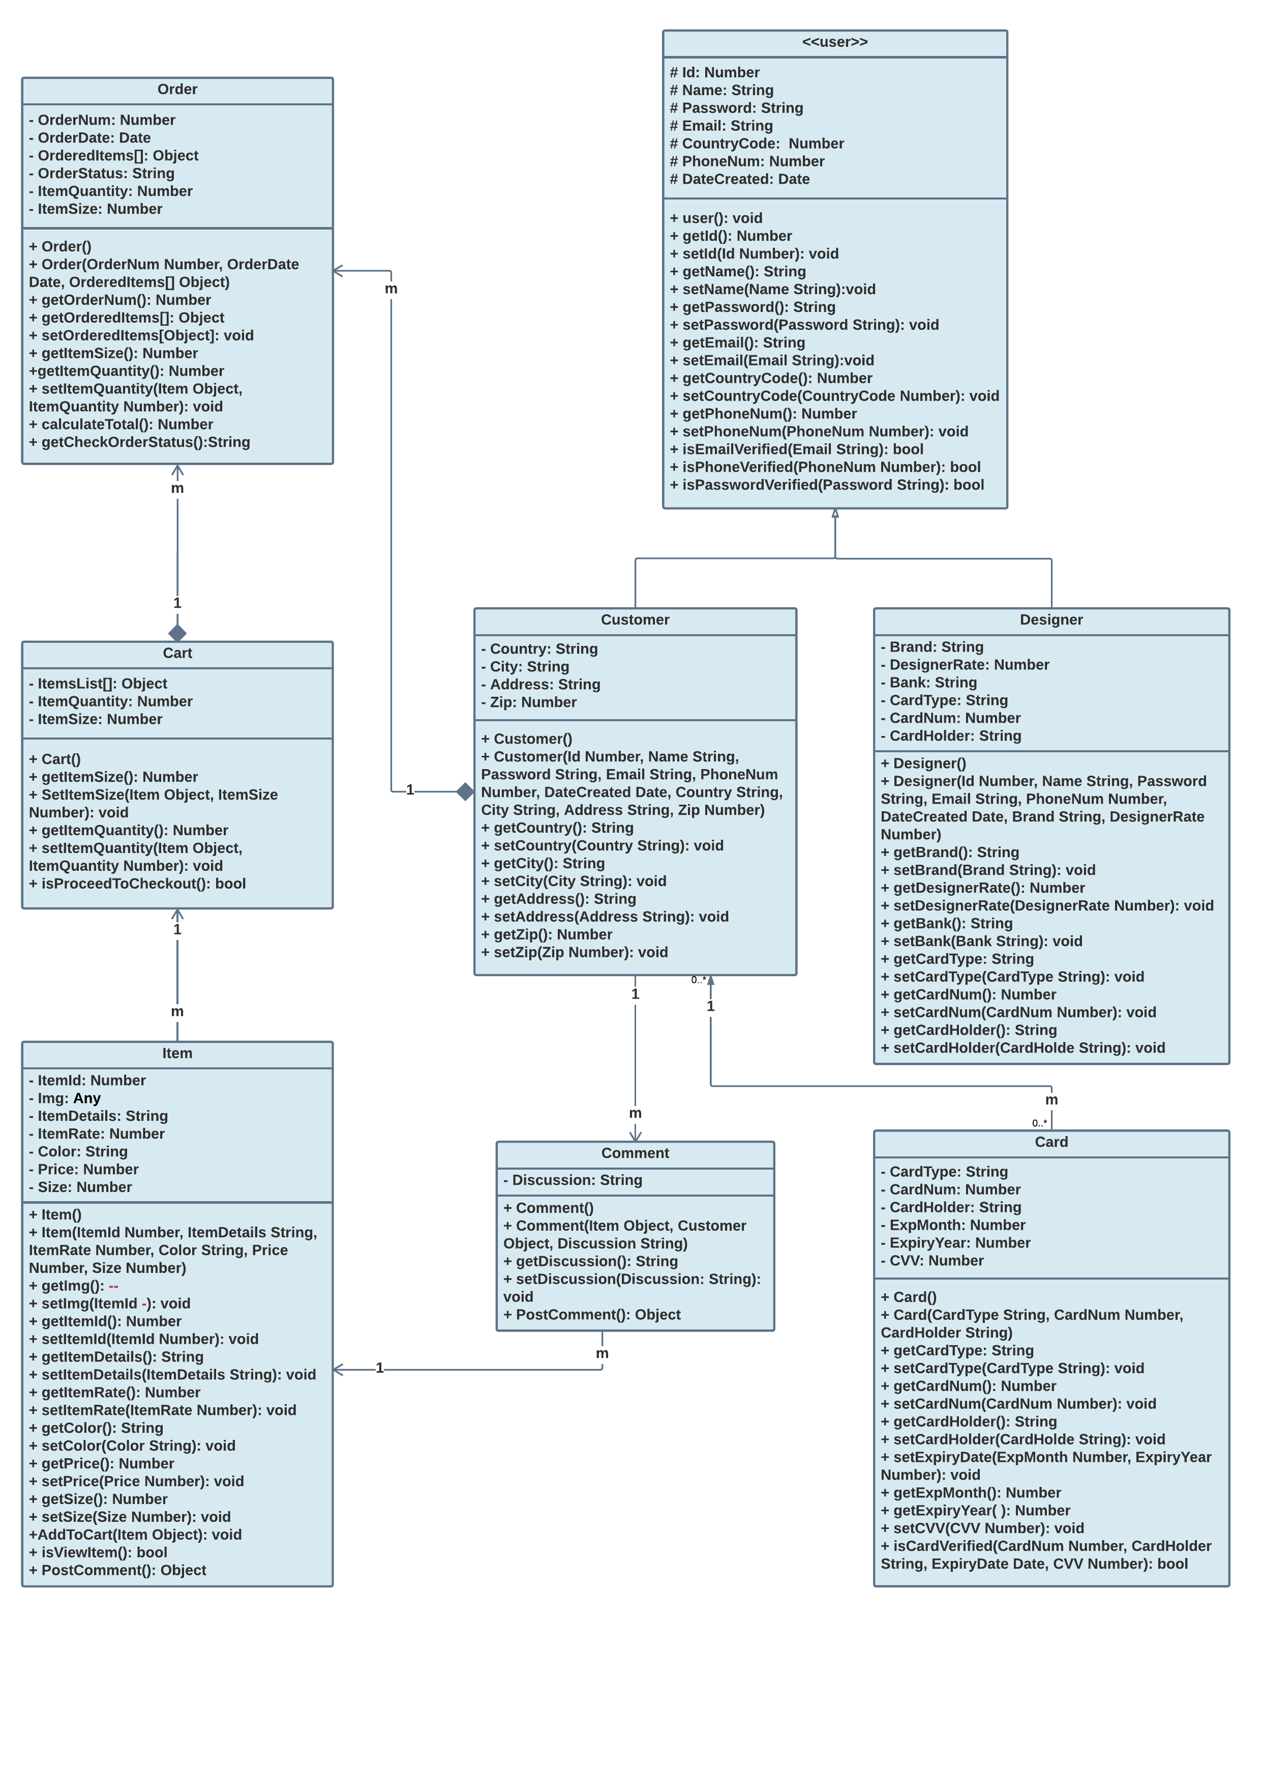

Figure 3.4: Class Diagram.

**3.1.5. ER Diagram** 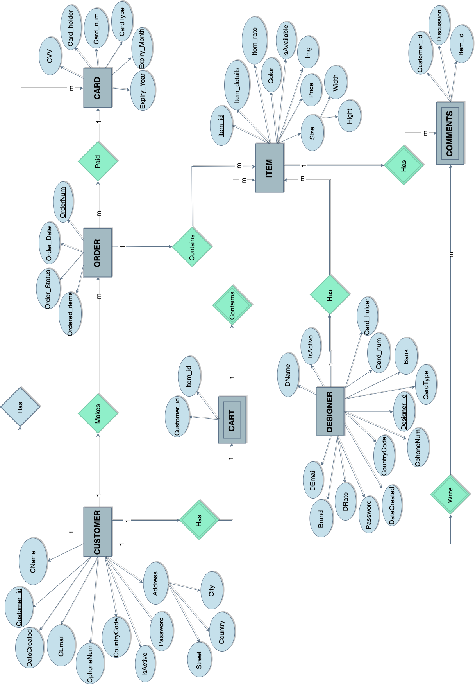

Figure 3.5: ER Diagram.

**3.1.6. Software and Hardware Requirements**

Operating System

* Microsoft Windows 8, 10
* Apple Mac OS
* Ubuntu

Browser

* Compatible browser (Chrome, Firefox,..)

Development Tools

* + Ionic v3
  + NodeJS v6.10.3 LTS
  + MongoDB v3.4.4
  + AngularJS v4.0
  + Git v2.12.2

Hardware Requirements

* CPU 64-bit or 32-bit Intel
* Internet Connection
* Graphics Card
* Disk Space 80 GB of free disk space for software installation and development
* iOS & Android phone.

**3.1.7. Project Plan**

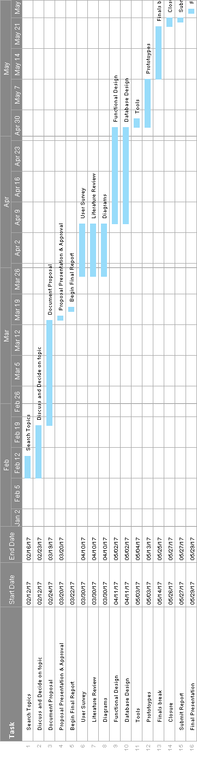

Figure 3.6: Plan for Graduation Project 1.



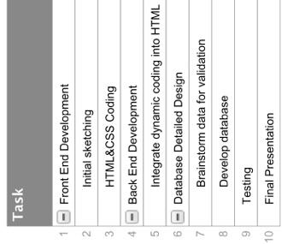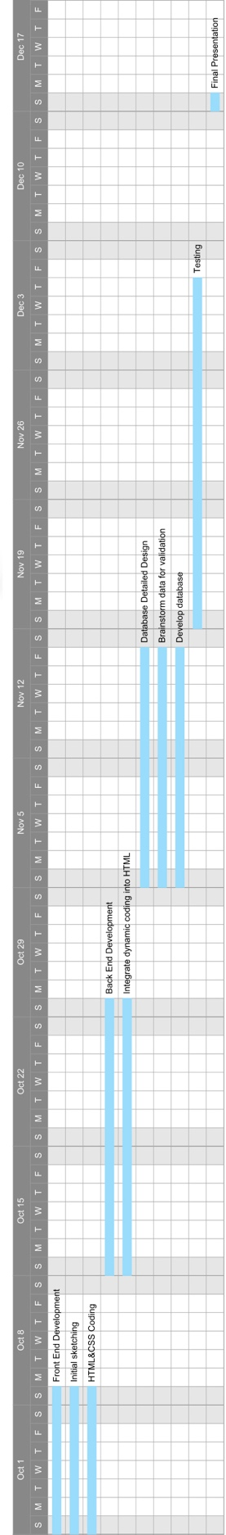

Figure 3.7: Plan for graduation project 2.

1. **Proposed System Design**
2. **Functional Design**
3. **Functional Requirements**

FE1: User login

FE2: User sign up as a customer or designer

FE3: Designer specifies boutique info

FE4: Designer adds new items

FE5: Designer can view her own collection

FE6: Designer view orders

FE7: Designer edit one’s profile

FE8: Customer view new arrival items

FE9: Customer adds items to the cart

FE10: Customer can edit one’s info

FE11: Customer can place an order

FE12: Customer can pay online

FE13: Send an email to the designer with the new order

FE14: Send an email to the customer to confirm the order

FE15: Send a verification email to verify users

1. **Methods**

|  |  |  |
| --- | --- | --- |
| Method Name (parameter) | Description | Return |
| calculateTotal() | Returns the total price of the order | Number |

Order

Table 3.5: Methods - Order.

|  |  |  |
| --- | --- | --- |
| Method Name (parameter) | Description | Return |
| addToCart(Item Object): | Adds the item selected by user to the cart | Null |
| isViewItem() | Redirects the user to the selected item page | Boolen |

Item

Table 3.6: Methods - Item.

|  |  |  |
| --- | --- | --- |
| Method Name (parameter) | Description | Return |
| isEmailVerified(Email String) | Compares the passed argument string to the emails stored in the database. | Boolen |
| isPhoneVerified(PhoneNum Number) | Compares the passed argument for the phone number to the already stored ones in the database. | Boolen |
| isPasswordVerified(Password String) | Compares the passed password argument to the one already stored in the database. | Boolen |

User

Table 3.7: Methods - User.

|  |  |  |
| --- | --- | --- |
| Method Name (parameter) | Description | Return |
| isCardVerified(CardNum Number, CardHolder String, ExpiryDate Date, CVV Number) | Checks credit card information | Boolen |

Card

Table 3.8: Methods - Card.

.

|  |  |  |
| --- | --- | --- |
| Method Name (parameter) | Description | Return |
| postComment() object | Submits comments entered by the user. | Object |

Comment

Table 3.9: Methods - Comment.

.

|  |  |  |
| --- | --- | --- |
| Method Name (parameter) | Description | Return |
| isProceedToCheckout() | Redirect to payment page | Boolen |

Cart

Table 3.10: Methods - Cart.

.

1. **Database Design**
2. **Schema**

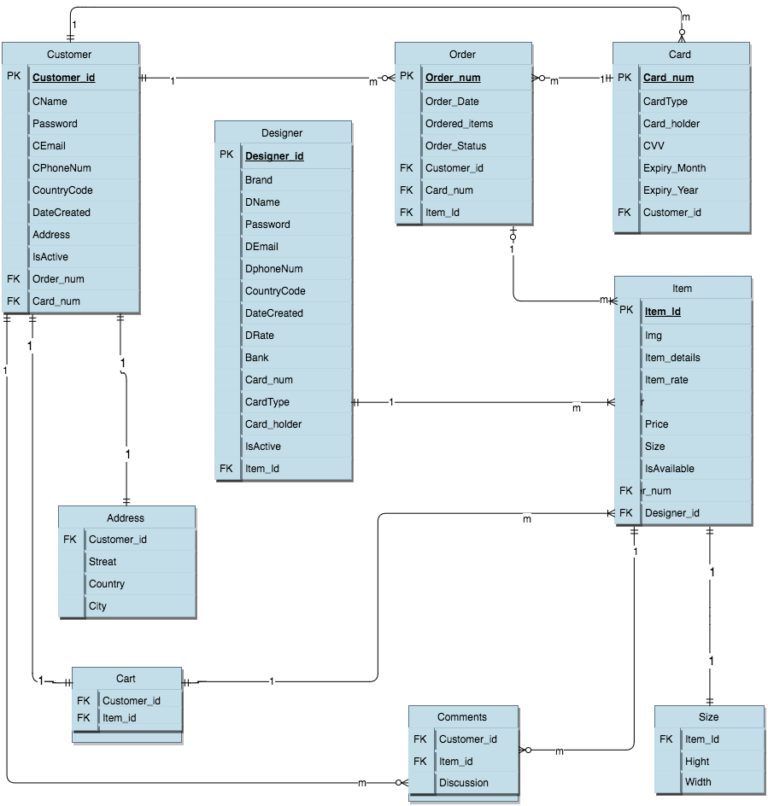

Figure 3.8: Database Design - Schema.

1. **Tables**

|  |  |  |
| --- | --- | --- |
| **Attribute** | **Data Type** | **Constraint** |
| Customer_id | Integer | PRIMARY KEY |
| CName | String | NOT NULL |
| Password | String | CHECK |
| CEmail | String | CHECK |
| CPhoneNumber | Number | CHECK |
| Address | Object | NOT NULL |

Customer

Table 3.11: Tables - Customer.

.

Designer

|  |  |  |
| --- | --- | --- |
| **Attribute** | **Data Type** | **Constraint** |
| Designer_id | Integer | PRIMARY KEY |
| Brand | String | UNIQUE |
| DName | String | NOT NULL |
| Password | String | CHECK |
| DEmail | String | CHECK |
| DPhoneNumber | Integer | CHECK |
| Designer_rate | Fraction | - |

Table 3.12: Tables - Designer.

.

Comment

|  |  |  |
| --- | --- | --- |
| **Attribute** | **Data Type** | **Constraint** |
| CName | String | FOREIGN KEY |
| Item_id | Integer | FOREIGN KEY |
| Discussion | String | - |

Table 3.13. Tables - Comment.

.

|  |  |  |
| --- | --- | --- |
| **Attribute** | **Data Type** | **Constraint** |
| Item_id | Integer | PRIMARY KEY |
| Item_details | Object | NOT NULL |
| Item_rate | Fraction | DEFAULT |
| Color | String | NOT NULL |
| Price | Fraction | NOT NULL |
| Size | Integer | NOT NULL |

Item

Table 3.14: Tables - Item.

.

|  |  |  |
| --- | --- | --- |
| **Attribute** | **Data Type** | **Constraint** |
| Order_num | Integer | PRIMARY KEY |
| Order_time | Date | NOT NULL |
| Ordered_items | Object | NOT NULL |
| Total | Fraction | NOT NULL |

Order

Table 3.15: Tables - Order.

.

|  |  |  |
| --- | --- | --- |
| **Attribute** | **Data Type** | **Constraint** |
| Card_num | Integer | CHECK |
| Card_holder | String | CHECK |
| Expiry_Date | Date | CHECK |
| CVV | Integer | CHECK |

Card

Table 3.16: Tables - Card.

.

1. **App Interface**

Primary colors: Secondary colors:

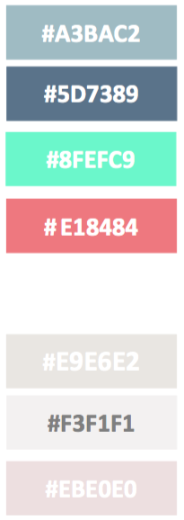 

The logo: Home Page:

 

The navigation: 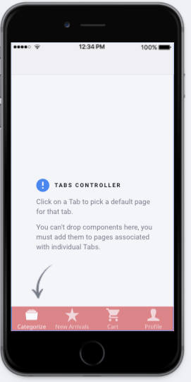

The categories: The new arrivals:

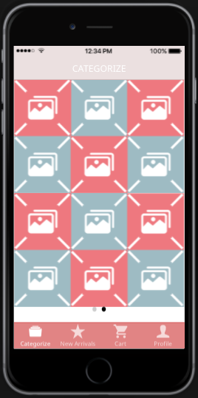 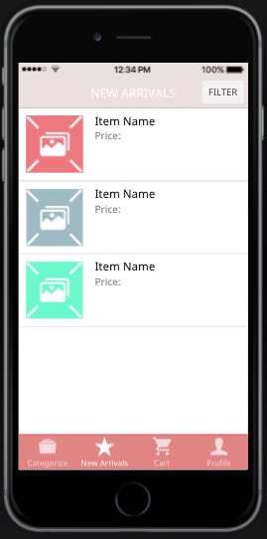

The shopping cart: The profile:

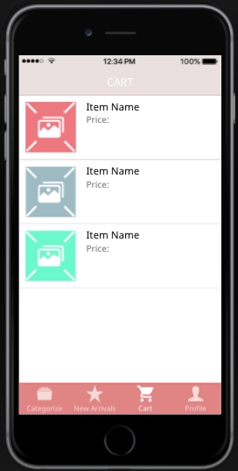 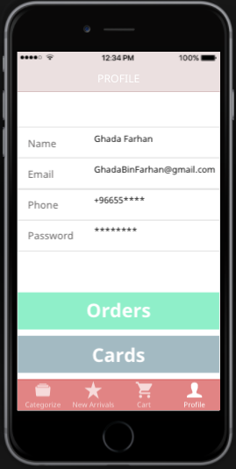

CHAPTER 4: DEVELOPMENT TOOLS



**Ionic3**

Ionic [4] is an open-source SDK for hybrid mobile app development for building highly interactive native and progressive web apps developed by Drifty. Users can build their apps, customize them for Android or iOS, and deploy through Cordova [5]. Ionic include mobile components, interactive paradigms, and a base theme.



Nginx

Nginx [6] is a web server, and reverse proxy, load balancer and HTTP cache. It is a free and open source software that can be deployed to serve dynamic HTTP content on the network using FastCGI, SCGI handlers for scripts, WSGI application servers. It can handle more than 10,000 connections at the same time with a low memory footprint and provide web page access authentication.



Node.JS

Node.js [7] is an open-source, cross-platform JavaScript environment for executing JavaScript code server-side. Originally, JavaScript was used primarily for client-side scripting to be run client-side by a JavaScript engine in the user's web browser. Node.js enables JavaScript to be used for server-side scripting to produce dynamic web page content before the page is sent to the user's web browser. Node.js is governed by the Node.js Foundation.



MongoDb

MongoDb [8] is developed by MongoDB Inc. It is a free and open-source cross-platform document-oriented NoSQL database program. MongoDB uses JSON-like documents, JavaScript Object Notation, with schemas. MongoDB scales horizontally. JavaScript can be used in queries and aggregation functions, and then sent directly to the database to be executed.



AngularJS

AngularJS [9] is an open-source JavaScript-based front-end web application framework. It is maintained by Google and by AngularJS community. It extends HTML library for applications to be more expressive, readable, and faster to develop. The JavaScript components complement Apache Cordova. The framework is used for developing cross-platform mobile apps. Its goal is to simplify the development and the testing by providing a framework for client-side (MVC).



Express.Js

Express.js [10], or Express, is a web application framework for Node.js, that provides a robust set of features for building single and multi-page, and hybrid web applications. It is a free and open-source software under the MIT License. It is developed for building web applications and APIs.



Stripe

Stripe [11] is a US technology company that allows private individuals and businesses to accept online payments. Stripe provides, fraud prevention, and banking infrastructure for online payment systems.



Git

Git [12] is a version control system (VCS) for tracking changes in files and coordinating the work on those files among people. It is mainly used for software development, but it also can be used to track the changes in any files. All Git directory on all computers are full-fledged repository with a full history and full version tracking abilities. It’s independent of network access or a central server.



Visual Studio Code

Visual Studio Code [13] is a free and open-source source code editor developed by Microsoft. It includes debugging, syntax highlighting, intelligent code completion, snippets, and code refactoring for many programming languages and a set of features that may or may not be available for a given language including C++, C#, CSS, Go, HTML, JavaScript, JSON, Python, Typescript and many more.



Lucidchart

Lucidchart [14] is a web-based service that allow working together at the same time to create UML diagrams, flowcharts, activity diagrams, organizational charts, software prototypes, and many other diagrams.



Draw IO

Draw IO [15] is an online free-to-license web diagramming application that is built around Google Drive but allows the users to store the diagrams in Google Drive, Dropbox or locally in their devices. It enables the users to create flowcharts, UML, ER diagrams, Gantt chart and more.



Adobe illustrator CC

Adobe Illustrator CC [16] is a vector graphics editor that is developed by Adobe Systems. It enables the user to create logos, drawings, icons, typography, and complex illustrations.



Heroku is a cloud platform as a service (PaaS) supporting several programming languages that is used as a web application deployment model. Heroku is said to be a polyglot platform as it lets the developer build, run and scale applications in a similar manner across all the languages.

CHAPTER 5: IMPLEMENTATION.

To develop this software, we used MEAN full-stack framework and Ionic front-end framework. MEAN stands for MongoDB, Express, AngularJS, Node.JS. We started the implementation by developing the iOS and android client-side app using Ionic3, that uses html, scss, and Typescript code. We develop the back-end inclemently after finishing each functionality of the fronted then test it.

Kessa has two views, the designer view and the customer view. We started by developing the login/signup process then moved on to the customer functionalities then the designer’s. After we are done with each frontend major functionality with ionic we developed the backend and database for it, tested the component then deployed it. We used Heroku cloud application platform for deployment.

The Fron-end

CHAPTER 6: TESTING.

During implementation, many errors and challenges were faced. These bugs and error led sometimes in changes in the design. Some of the most significant errors are listed down below.

CHAPTER 6: CONCLUSION AND PLAN AHEAD.

The proposed system is aimed to unify Abaya designers and customers in one mobile platform to sell Abayas. currently, customers are having numerous problems in ordering from designer Abaya’s, which is analyzed and inferred from the user survey. Furthermore, the system aim is to support small Abaya designers’ businesses, in addition to the sales reports system feature and many more features will make the shopping experience for Abayas more convenient and beneficial for both customers and designers in terms of time and effort. Indeed, numbers have shown that the system is almost essential for women in the gulf region for their high demand in purchasing designer Abayas will surely show success in developing the proposed system.

FE8: Customer rate item

FE9: Customer rate designer

FE11: Designer view statistics

FE8: Customer rate item

FE9: Customer rate designer

FE11: Designer view statistics

FE13: Admin verifies designer account

FE14: Admin updates designer's database

FE15: Admin verify items

FE16: Send an email to the designer with the new order

FE17: Send an email to the customer to confirm the order

FE18: Send a verification email to verify users

FE19: Send an SMS message to the user to verify phone number

CHAPTER 7: REFERENCES

1. Kuar, K.D.,Din,D.S., 2013. An Online Purchase Portal for Books and Seeds in Regional Language (Punjabi). International Journal of Advanced Research in Computer and Communication Engineering, 2/10, 5.
2. Kodali, K.S.,2007. The design and implementation of an E-Commerce site for online book sale.
3. SurveyMonkey: Free online survey software & questionnaire tool. 2017. [ONLINE] Available at: https://www.surveymonkey.com/.
4. ionic.io. 2017. No page title. [ONLINE] Available at: http://ionic.io/2.
5. Apache Cordova. 2017. Apache Cordova. [ONLINE] Available at: https://cordova.apache.org/.
6. Welcome to NGINX Wiki! | NGINX. 2017. Welcome to NGINX Wiki! | NGINX. [ONLINE] Available at: https://www.nginx.com/resources/wiki/.
7. Node.js Foundation. 2017. Node.js. [ONLINE] Available at: https://nodejs.org/en/.
8. MongoDB. 2017. MongoDB for GIANT Ideas | MongoDB. [ONLINE] Available at: https://www.mongodb.com.
9. AngularJS — Superheroic JavaScript MVW Framework. 2017. AngularJS — Superheroic JavaScript MVW Framework. [ONLINE] Available at: https://angularjs.org.
10. Express - Node.js web application framework. 2017. Express - Node.js web application framework. [ONLINE] Available at: https://expressjs.com/.
11. Stripe. 2017. Stripe. [ONLINE] Available at: https://stripe.com/.
12. Git. 2017. Git. [ONLINE] Available at: https://git-scm.com/.
13. Visual Studio Code - Code Editing. Redefined. 2017. Visual Studio Code - Code Editing. Redefined. [ONLINE] Available at: https://code.visualstudio.com/.
14. Lucidchart. 2017. Flowchart Maker & Online Diagram Software | Lucidchart. [ONLINE] Available at: https://www.lucidchart.com/.
15. Flowchart Maker & Online Diagram Software. 2017. Flowchart Maker & Online Diagram Software. [ONLINE] Available at: https://www.draw.io/
16. Buy Adobe Illustrator CC | Download graphic design software free trial. 2017. Buy Adobe Illustrator CC | Download graphic design software free trial. [ONLINE] Available at: <http://www.adobe.com/mena_en/products/illustrator.html>.
17. Mongo Express Angular Node. 2017. home - Mongo Express Angular Node. [ONLINE] Available at: http://mean.io/.

APPENDIX A: CUSTOMER’S SURVEY RESULT SCREANSHOTS

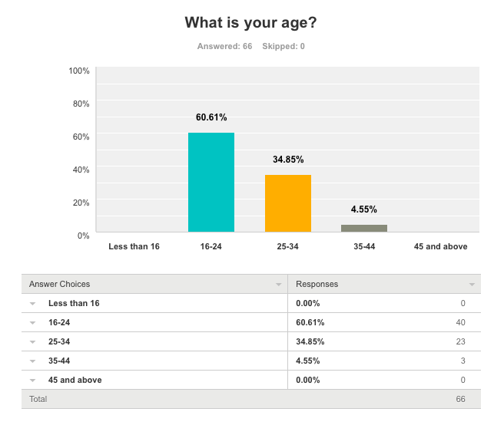

Figure A.1: Survey on customer’s age.

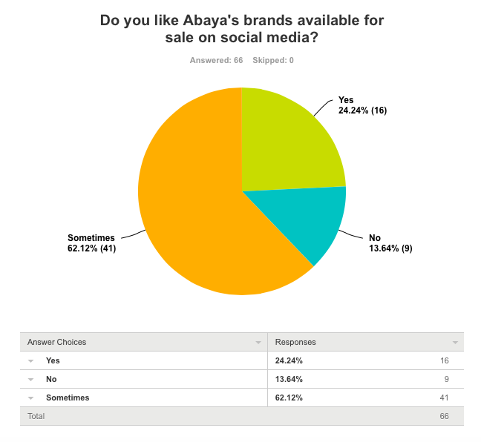

Figure A.2: survey on customer’s interest on social media brands.

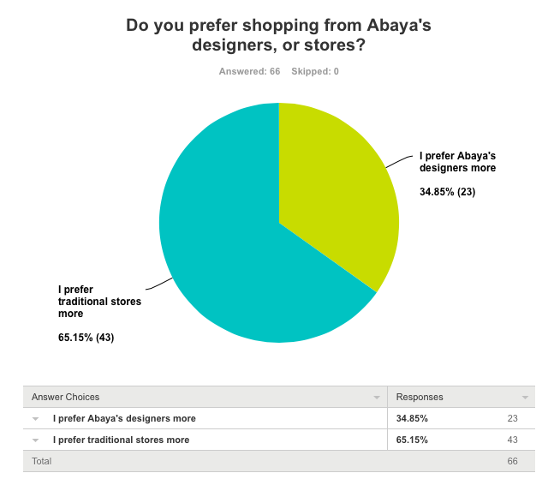

Figure A.3: Survey on shopping preferences.

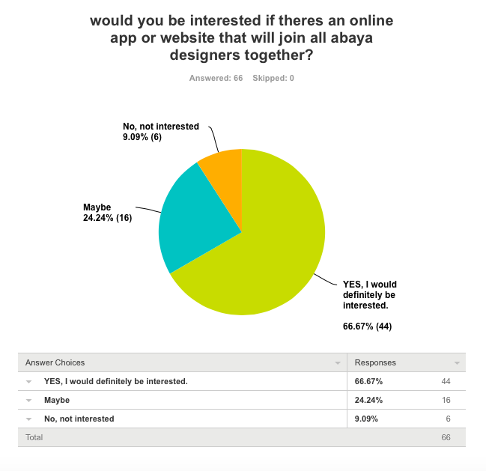

Figure A.4: survey on customer interest on Abaya app/website.

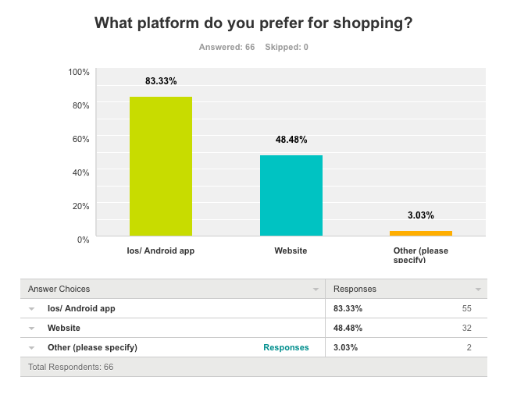

Figure A.5: Survey on platform preferences.

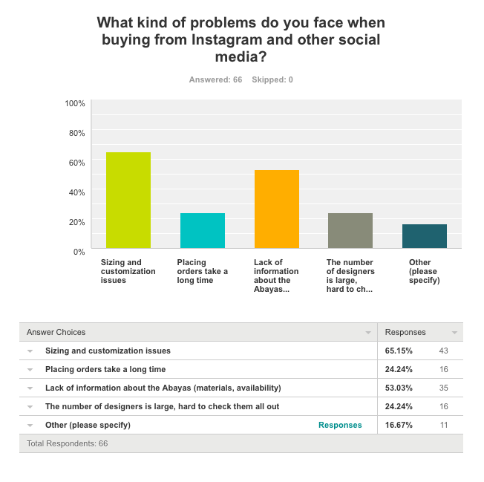

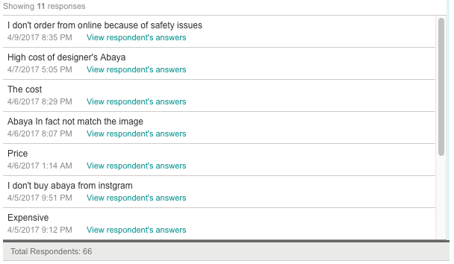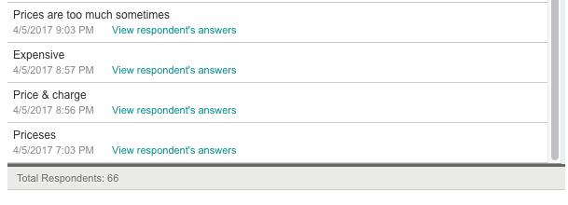

Figure A.6: Survey on problems in Instagram businesses.

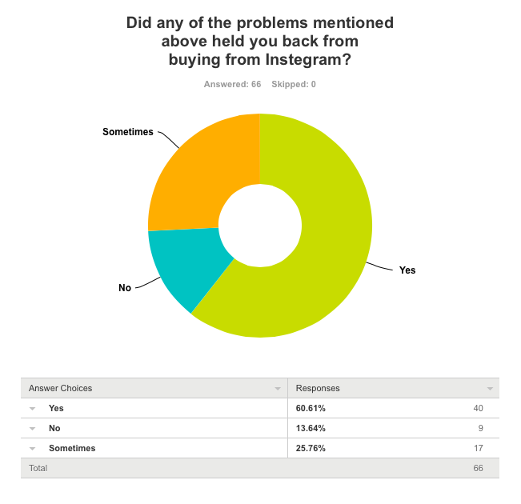

Figure A.7: Survey on percentage of preventative reasons.

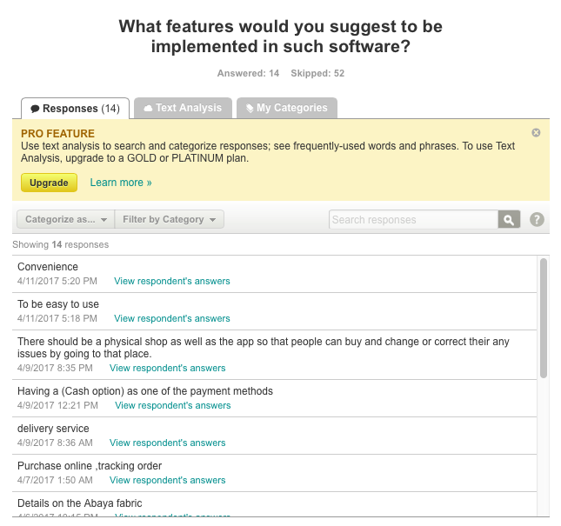

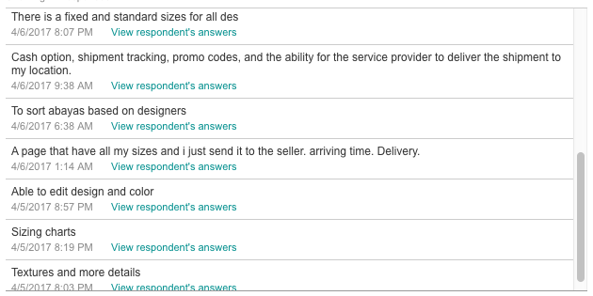

Figure A.8: Survey on customers’ suggestion.

APPENDIX B: DESIGNERS’ SURVEY RESULT SCREANSHOTS

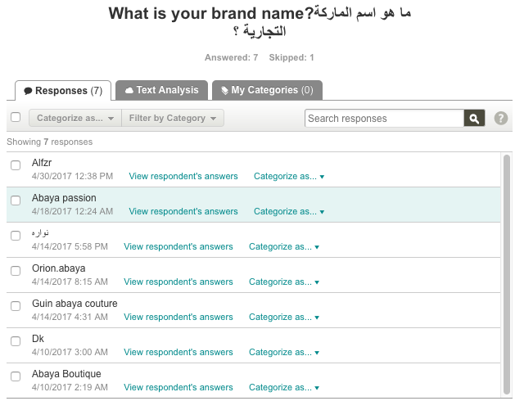

Figure B.1: Survey on brand names.

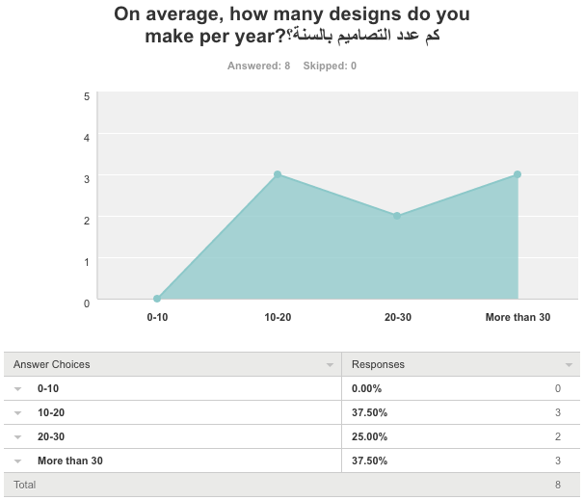

Figure A.2: Survey on number of designs.

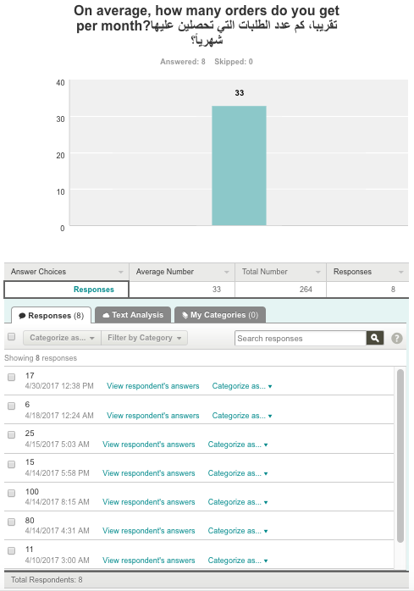

Figure B.3: Survey on designers’ monthly orders.

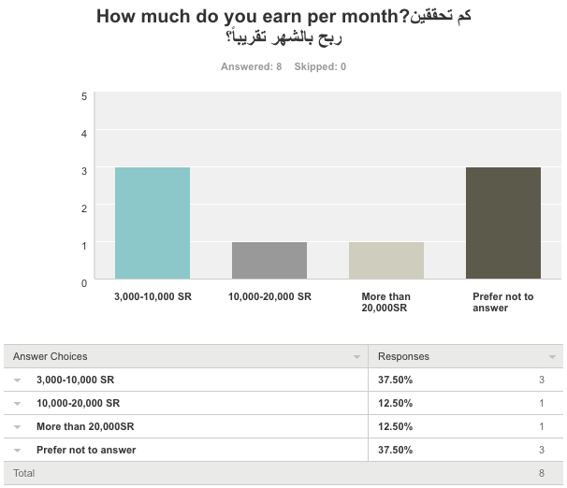

Figure B.4: Survey on designers’ monthly earnings.

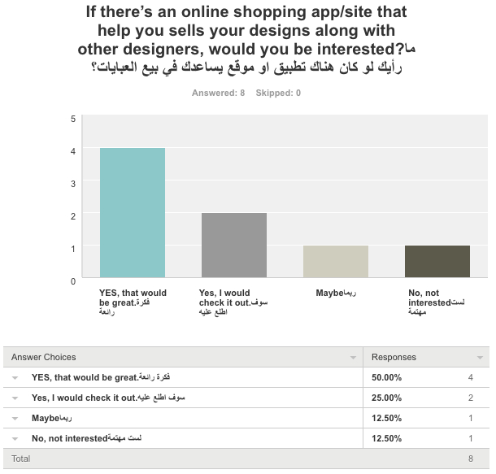

Figure B.5: survey on sells preferences.

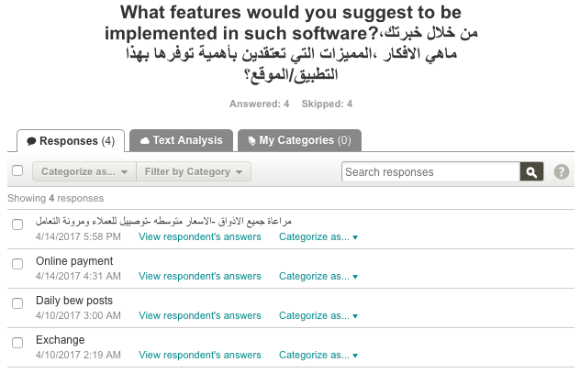

Figure B.6: Survey on designers’ suggestion.

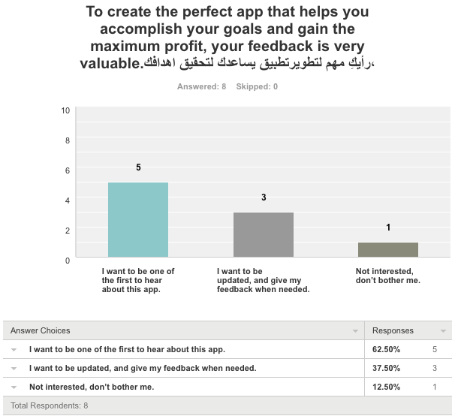

Figure B.7: Survey on interest to be involved in creating the app.

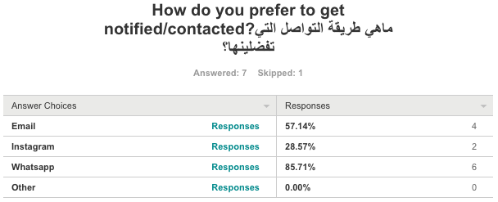

Figure B.8: Survey on preferred contact methods.